

Capstone Project Phase B

Smell Classification and Identification

**“Smelltify”**

24-1-R-1



Supervisor: Mr. Ilya Zeldner

Liel Pasman: Liel.Pasmanl@e.braude.ac.il

Amit Malca: Amit.Malca@e.braude.ac.il

# Table of Contents

Table of Contents 2

Abstract 4

1. Introduction 5

1.1 The importance of smell analysis 5

1.2 How we smell 5

1.3 The challenges in smell analysis 6

2.Background and Related Work 7

2.1 Principal Odor Map 7

2.2 The Chosen Model and Evaluation Algorithms 9

2.2.1 K-fold Cross Validation 10

2.2.2 ADASYN oversampling 11

2.2.3 Grid Search cv - Cross Validation 12

2.2.4 Gardient Boosting Machine 13

2.2.5 Adaboost 14

2.2.6 Random Forest 16

2.2.7 Support Vector Machine 17

2.2.8 k- nearest neighbors(k-NN) 17

2.2.9 Boruta features selection 18

2.2.10 XGBoost 19

3. Proposed Approach 20

“smelltify” 20

3.1 Architecture and technologies 20

3.2 Main architecture 21

4. Engineering Process 22

4.1 Process 22

4.2 Dataset 22

4.3 Challenges and solutions 22

4.4 Product 23

4.4.1 Use Case Diagram 23

4.4.2 Activity Diagram 24

5. Verification 24

6. Results and conclusions 29

7.User Guide 30

8. Maintenance Guide 33

**Work Environment:** 33

**Installations:** 33

Backend: 33

Frontend: 33

**Running the Project:** 33

Frontend: 33

**Important Notes:** 34

References 35

# Abstract

In addressing the complex challenges of smell classification and identification, our research leverages advanced machine-learning algorithms. The primary goal is to develop tools that can solve smell-related issues across various industries such as perfumery, technology, communication, and beyond by identifying, creating, and adapting to specific scents. Our algorithm is based on a series of studies that investigate diverse algorithms for smell detection and classification. These include data-driven techniques that predict the structural properties of odorous molecules and their relationship to smell perception. This project stands on the shoulders of extensive previous research, combining techniques such as Convolutional Neural Networks (CNN) and Extreme Gradient Boosting (XGBoost) to refine our predictive capabilities. Our goal is to create a reliable system for detecting and classifying smells. By harnessing the potential of machine learning and artificial intelligence, we aim to bring a new level of precision and understanding to the field of olfaction, offering innovative solution that can benefit various subjects.

**Keywords**

Smell, Identification, Classification,

# Introduction

## 1.1 The importance of smell analysis

Smell analysis is essential for many reasons. In the field of perfumery and cosmetics, the creation of new fragrances requires an understanding of how different molecules interact with smell receptors. In the food industry, analyzing and replicating smells can enhance taste experiences. In technology and communication, smell analysis can be used to develop electronic noses, which can have applications in safety, quality control, and even in the digital transmission of smell. Imagine a situation where you see a cooking program on TV and are able to smell the smell of the dishes being cooked in the program in your living room. This is something that smell analysis could make possible. Based on our research and utilizing an existing database[16], we aim to fulfill the project's goal: to develop an application capable of identifying new smells and matching and classifying them with known smells according to numerous smell categories. This capability will allow the information to be used in various fields, a significant advancement in smells technology that has not yet been achieved[1] [2].

## 1.2 How we smell

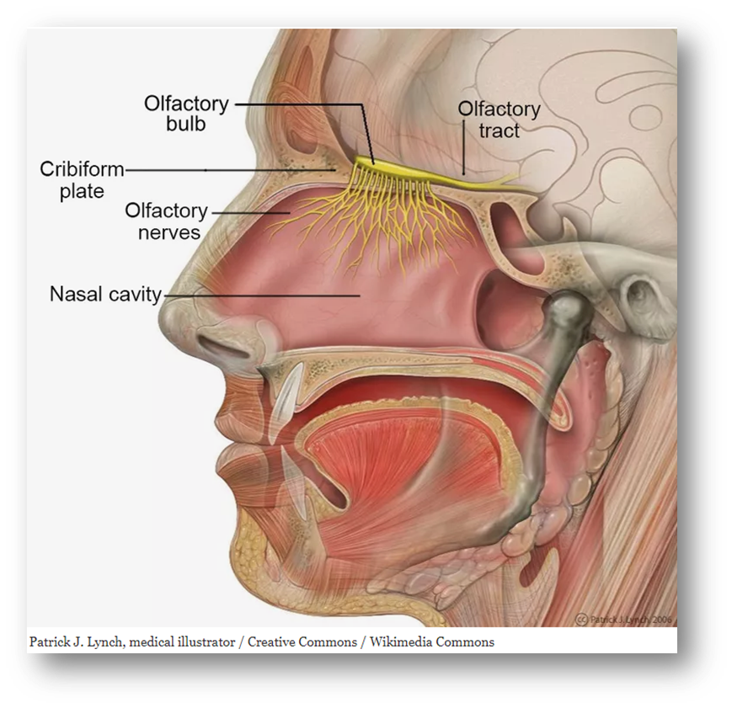

Figure 1:Olfactory System Structures

Smells are an integral part of our daily life, there is a wide variety of types of smells that we describe as sweet, spicy, musky and more. The smells are produced by billions of molecules that can change in many ways, which pass through the air and enter our nose, which contains more than 300 receptors - smell-receiving cells, to smell and bind to these receptors [2]. The process of smelling is carried out as follows(see figure above): in the first stage, the smell molecules in the air enter the nose and dissolve in the mucous membrane of the olfactory epithelium (a special cell tissue in the nose that contains the smell receptors). These molecules bind to specific receptors on the cilia of the olfactory sensory neurons (special neurons that detect smells). In the second stage, the molecules bind to specific receptors on the cilia of the olfactory sensory neurons. Each receptor is sensitive to certain molecular properties or structures, which allow the nose to detect a wide variety of smells.In the third stage, the binding causes a chain of molecular reactions within the olfactory neurons, which leads to the creation of an electrical signal (nerve impulse, the electrical action transmitted by the nerve cells). This signal is sent to the olfactory bulb (a structure in the brain that receives and processes the smell information). The olfactory bulb processes the signals and serves as a transit station, transmitting the information to other areas of the brain involved in the sense of smell.In the last stage, the olfactory bulb transmits the information to the olfactory cortex (the part of the brain that processes the sensory information from smells) and other areas of the brain involved in the perception of smell, such as the limbic system (a group of structures in the brain related to emotions and memory). This processing allows the brain to interpret the signals as specific smells [2].(see figure 1)

## 1.3 The challenges in smell analysis

A molecule can be called an odorant only if it meets the following two conditions: (1) the molecule must be volatile enough to pass from the air to the nose and contact the receptors there, meaning it must have a low molecular weight and a certain repulsion from water [2]. (2) The molecule must trigger a chemical message that can be converted into a nerve impulse [2]. There is a lack of uniformity in two directions. First, the same smell can be produced from different combinations, making it difficult to classify which molecules produce which smells [2]. Additionally, collecting data for smell analysis requires physical proximity between the smell and the smeller, and everyone can perceive the same smell differently. Therefore, the sense of smell is the most difficult sense to analyze [1]. Developments in machine learning have led to the use of data-driven approaches to predict how the structural properties of odorant molecules relate to smell perception [2]. Different databases and methods have been utilized, including data from both trained and untrained individuals, which poses challenging comparisons [2]. Previous studies used various methodologies and tools to tackle the problem of smell classification and prediction. For instance, some studies used arrays and different machine learning techniques, such as random forest algorithms, which are designed for classification and regression tasks by combining multiple decision trees to produce accurate predictions [2].

However, these studies encountered several challenges. One significant issue was the imbalance in the datasets, where certain smell classes were underrepresented. To address this, researchers used oversampling techniques, but these methods had their limitations, particularly in the chemical interpretation of the results [2]. In addition to random forests, CNN-based predictive models were also developed to analyze smell characteristics and smell pleasantness. While these models showed success in classifying sweet smells, they struggled with other types of smells. Another limitation of these studies was their ability to compare and classify only two smells at a time, which restricted the comprehensive analysis of a broader range of smells [2][1]. In summary, although previous research has made significant steps in using machine learning for smell prediction, it has been limited by dataset imbalance, the complexity of chemical interpretation, and limitations in the scope of smell classification. highlight the need for more accurate and comprehensive models to improve the accuracy and applicability of technologies related to smell detection and classification. Our goal: build an application that capable of identifying new smells, matching and classifying them with known smells according to numerous smell categories.

# 2.Background and Related Work

## 2.1 Principal Odor Map

As we explained earlier, it is difficult to classify which molecules produce which smells. Additionally, collecting data for odor analysis requires physical proximity between the odorant and the person smelling it, and everyone can perceive the same odor differently. As a result, there has been a lack of useful maps for smell—maps that can help identify and predict odors based on the chemical structure of the molecules[1].

In 2019, the research team at Google Research led by Richard C. Gerkin and Alexander B.Wiltschko developed a GNN model that studied thousands of different molecules to learn about the relationship between the molecule and the probability that it would exhibit certain odor characteristics[1]. In the model, each molecule is represented by a vector that describes its smell. Using this model, they created the Principal Odor Map (POM). The map (see figure 1) shows the odor molecules in a multidimensional space (more than 3D), where each molecule is represented as a single point. In this map, two points close to each other represent pairs of similar smells. Using the map, it is possible to predict new smells and identify which molecules correspond to them.

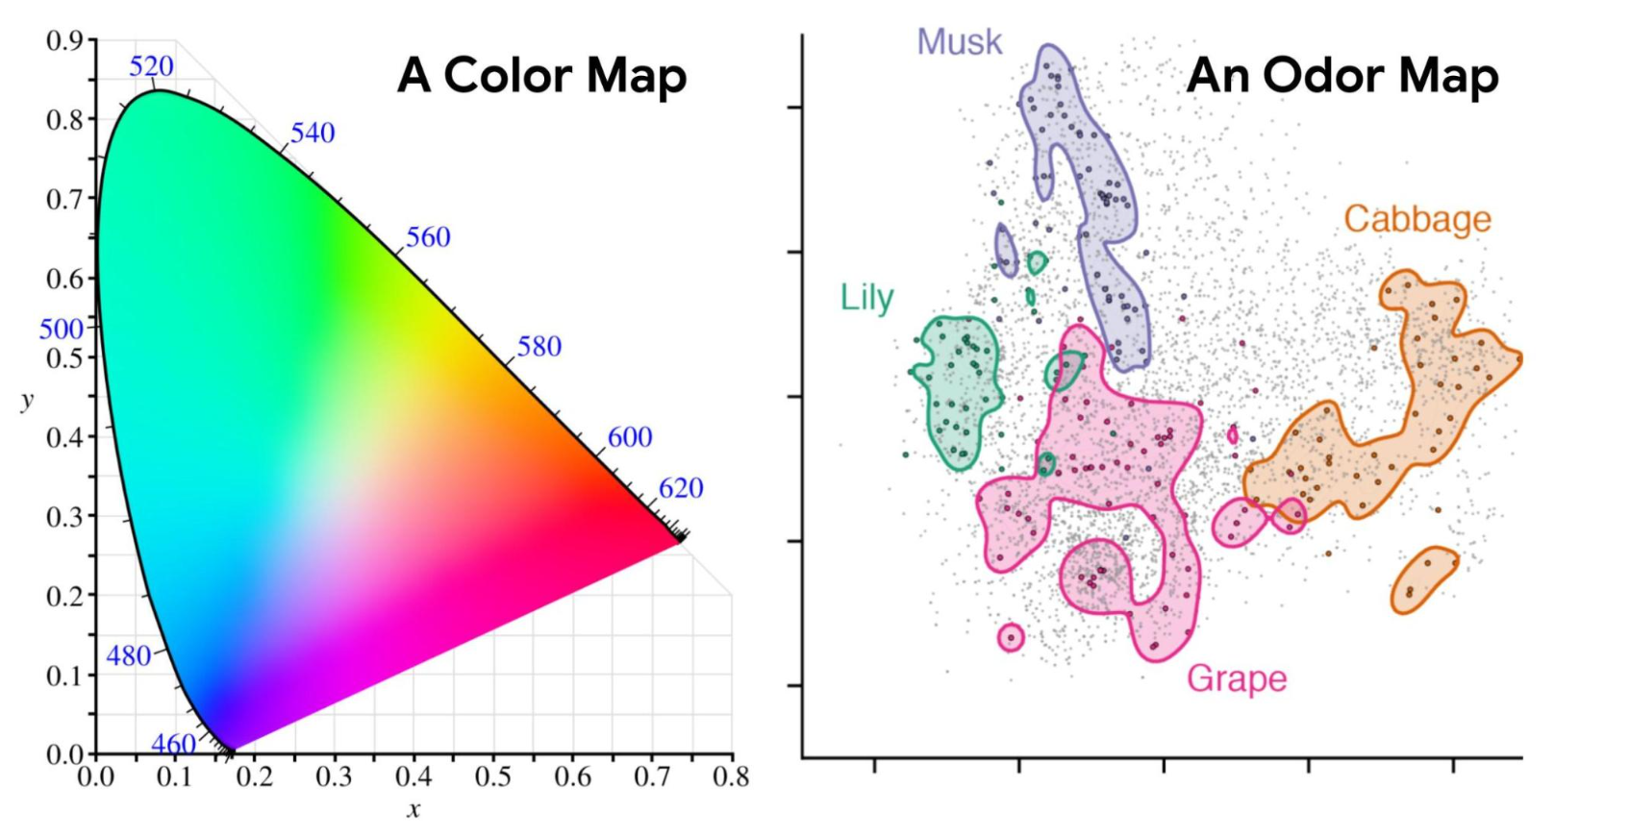

Figure 2: Odors in the Principal Odor Map operate similarly. Individual molecules correspond to points (grey), and the locations of these points reflect predictions of their odor character. [Gerkin and Wiltschko, 2022].

In the first test, the researchers examined whether the model could correctly predict the odors of new molecules that no human had smelled before, and which were very different from those used during the model's development. First, the panel members were trained to rate the smell of each of 400 different molecules according to 55 odor labels, such as "sweet" and "mint." These labels were chosen to cover the space of possible smells without redundancy. Thus, the largest dataset of odor descriptors for new molecules was collected. The study revealed that each person characterizes the same molecule differently, so the researchers assessed how well the model could fit the average ratings of all panel participants. The results showed that the model's predictions were closer to the average results of all panel members, demonstrating that the model can predict odors well from the molecular structure [1].

In the second test, the researchers checked whether the POM could predict odor perceptions in animals, not just humans. They collected data on metabolic responses in different species of animals. They discovered that the POM corresponded to the structure of metabolism itself, indicating that if two molecules were far apart in terms of smell on the map, a large number of metabolic reactions were required to convert one to the other. Additionally, naturally occurring molecules in the same substances were found close to each other on the map. The POM captures basic biological principles, showing how the sense of smell helps living things navigate their environment and respond to metabolic cues [1].

In the latest test, the POM was used with new datasets and predictive models to identify mosquito repellents. The new repellents discovered were more effective, cheaper, and more durable than existing ones, offering solutions to combat diseases transmitted by mosquitoes and ticks [1].

In our project, we aim to propose an additional implementation that will lead to more accurate results for the classification and identification of smells. We will use this model as a benchmark for the results we achieve in developing our algorithm, ensuring that our approach is validated against an established standard and indeed produces better results. (see figure 2)

## 2.2 The Chosen Model and Evaluation Algorithms

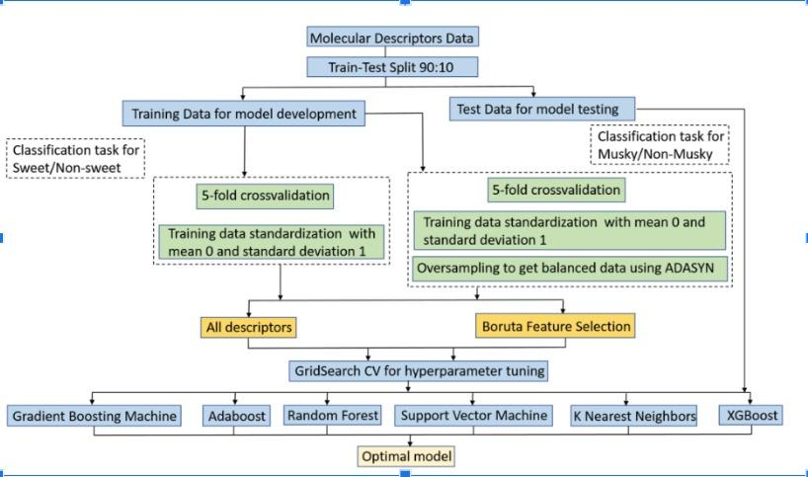

Figure 9: Overall workflow of model development for the classification tasks

Based on previous studies and models, and leveraging advancements in machine learning, researchers have developed a model for smell classification to determine the optimal algorithm for this purpose. Our research builds on these foundations by investigating the test model and the optimal XGBoost model.

The algorithm tested various approaches to identify which one yielded the best results for smell classification. The following algorithms were evaluated (as will be described in detail below): random forest, gradient boosting, support vector machine, adaptive boosting, and extreme gradient boosting (XGBoost).The evaluation process involved dividing the data into training and testing sets with a 9:1 ratio. A five-fold cross-validation approach was used to ensure the model's generalizability. The performance metric employed was the F1-Score, which is the harmonic mean of precision and recall.

Among these, the XGBoost model was found to be the optimal algorithm (see table below). XGBoost is a powerful ensemble learning method that uses boosting to improve the performance of weak learners, typically decision trees. It is known for its speed and performance, making it suitable for large-scale and complex datasets. Our research focuses on refining and implementing this model to achieve accurate and reliable results in smell classification. Now we will briefly describe each algorithm the model uses.

Performance of Classification Algorithms for "Sweet" and "Musky" OC Labels:

|  |  |  |  |
| --- | --- | --- | --- |
| **Algorithm** | **Train F1-Score** | **Validation F1-Score** | **Test F1-Score** |
| Gradient Boosting | 0.816 | 0.785 | 0.813 |
| AdaBoost | 0.789 | 0.768 | 0.823 |
| Random Forest | 0.818 | 0.785 | 0.824 |
| Support Vector Machine | 0.754 | 0.732 | 0.781 |
| XGBoost | 0.799 | 0.774 | 0.84 |
| K-Nearest Neighbors | 0.784 | 0.773 | 0.838 |

### 2.2.1 K-fold Cross Validation

K-fold cross validation [3] is a technique used in machine learning to evaluate the performance of a machine learning model. By dividing the dataset into k groups of equal size, called folds. After that, the algorithm iteratively trains the model k times, each time using a different fold as test and the remaining folds as train.

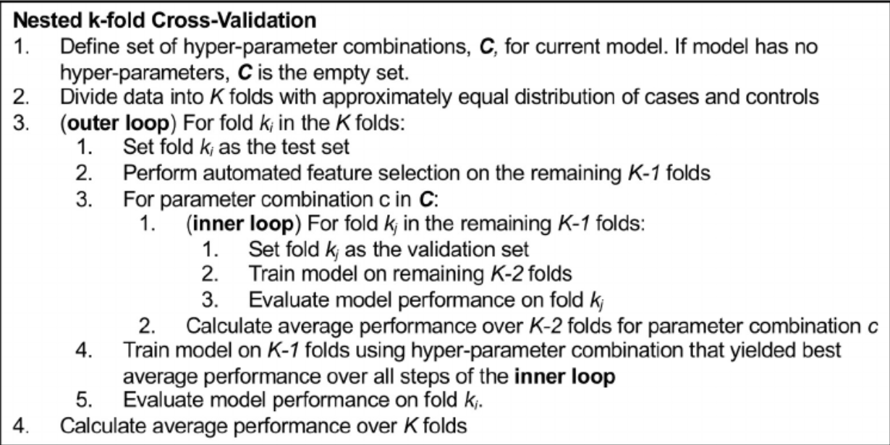

figure 3: K-fold pseudo code [3]

First, in general, the function receives the data and the number of parts it needs to divide into and outputs the average result of the accuracy of the prediction (prediction).

Now we will expand on the algorithm:

In the first step we will divide the algorithm into K equal parts completely randomly

Then in a loop for each part (fold) we will perform:

We will divide the data into train and test so that the current part is the test while the rest of the data is the train

And trust our model according to the train

After that we will run our model on the current test

We will save the results in a list and repeat the loop as the number of parts

Finally after all the runs we calculate the average result and return it.(see figure 3)

### 2.2.2 ADASYN oversampling

Adaptive Synthetic Sampling Approach for Imbalanced Learning (ADASYN) creates synthetic samples of the data in order to get more samples for labels which have small amounts of samples. That operation helps to classify better labels with small amounts of samples.   
**how it works:**

1.Calculate Class Imbalance- calculate the imbalance between labels with a big amount of data and small amount of data.

2.Compute KNN- for each minority group ( label with small amount of samples), compute its KNN

3.Estimate Density Distribution: Calculate the density distribution of the minority class by estimating the ratio of the number of majority class( label with small amount of samples) samples to the total number of samples in the k-nearest neighbors of each minority class instance.

4.Generate Synthetic Samples: For each minority instance, the number of synthetic samples to be generated is proportional to its difficulty level,which means instances in sparse areas will generate more samples.

### 2.2.3 Grid Search cv - Cross Validation

First, we will explain what hyperparameters are and the difference between them and parameters [4]. Parameters and hyperparameters belong to a machine learning algorithm but each is used for different tasks.

Parameters are values that are learned by the algorithm for making predictions, so the user does not define them beforehand. The algorithm discovers those parameter settings while training based on the data it sees. The parameters are what help the algorithm make more accurate predictions when receiving new data.

These hyperparameters are values that are determined by the user before, that is, during the construction of the model for machine learning, they are used to estimate optimal parameters for the model.

Gridsearch and GridsearchCV that included cross validation is used to search for the best hyperparameters.

In cross-validation in the model, the data is divided into training data and validation data, usually, the division is according to K groups so that in each iteration a group is selected for validation and K-1 groups for training.

now we will explain how gridsearchCV works [5]:

In the first step, a group of hyperparameters and their param_grid values are defined, the group usually consists of a dictionary whose keys are parameter names and lists of definitions defined as values or a list of dictionaries.

Then using the function `all_combinations(param_grid)' the algorithm tries all possible combinations of the hyperparameters so that a grid is created in which each dot represents a different unique combination.

In the next step, cross-validation is performed using the function cross_validate(estimator, cv)` The estimator indicates the machine learning model or algorithm that we want to train and the variable cv indicates the strategy for performing the cross-validation, usually this is a number indicating the number of folds.

The function splits the data according to the cv into several subgroups and for each fold it trains the model on the training subgroup and evaluates the model according to the validation subgroup and ultimately records the evaluation dimensions.

After performing these steps on all subgroups it returns the results usually all scores obtained for each subgroup-fold.

In the next step the `compute_mean_score(cv_results, scoring)` function calculates the mean score for each combination of hyperparameters based on the cross-validation results (`cv_results`) which usually include the scores for each fold subgroup and a defined scoring index (`score`) which is usually accuracy.

In the final stage, the algorithm returns the model with the best performance with the set of hyperparameters that created it, ``best_estimator`', ``best_params`' respectively.

### 2.2.4 Gardient Boosting Machine

An ensemble machine learning technique[6] (using the predictions of several learning models to improve results) used for regression and classification tasks. This is a strong predictive model that uses a combination of simpler models - "weak" models, usually decision trees. The algorithm each time compares the residuals that are obtained - the predicted values minus the target values In practice and thus at each step the algorithm learns and reduces the remainder so that the algorithm improves the forecast in each iteration.

Now we will describe the code of the algorithm:

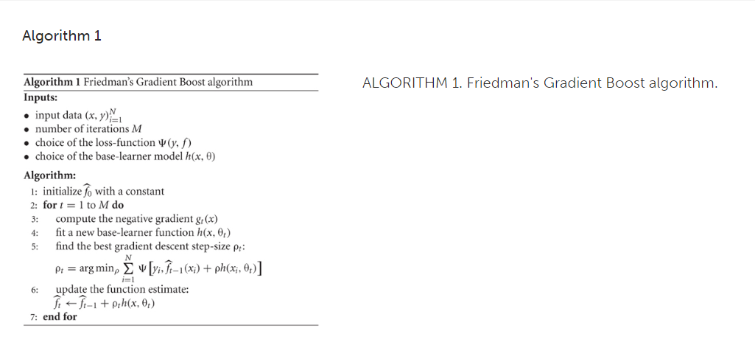

Figure 4: Gradient Boost pseudo code

The algorithm receives as inputs the following parameters: an array of data such that x is a vector in which each component represents an explanatory variable or a feature, this is the input feature vector and y is the corresponding label belonging to each instance of data, that is, the quantity we want to predict or evaluate according to the input features.

M is the number of iterations that the loop will be executed, this is a variable determined by the user usually by experiments and cross-validation for the value that will give the best result.

Ψ(y,f) represents the loss function that defines the gap between the predicted values f and the real target values y.

h(x,θ) is the function used to construct the solution and is based on a learning model so that θ represents the present values of the parameters in the model.

The course of the algorithm:

Initialize f_0 with a constant usually chosen as the average of y and represents the initial guess.

Then the following steps are performed in a loop M times:

1.Calculation of the negative slope-negative gradient, for each x_i, that is, the negative ratio between the loss function to the estimate of the current 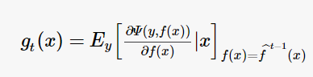

function according to the following formula:

2.Based on the negative gradient we now fit a new learning function so that it links the x ie the features to the negative gradient.

3. Now the alg finds the value of ρ_t whose purpose is to minimize the loss caused by the model's predictions compared to the real labels y while considering the contribution of the learning model.

4.The function estimate is updated by adding the contribution of the learning model according to the step size ρ_t in order to improve the function estimate before minimizing the overall loss function. In the equation f_t is the estimate of the updated function after iteration t and f_t-1 is the estimate of the function from the previous iteration.(see figure 4)

### 2.2.5 Adaboost

Adaptive Boosting[7], is an ensemble learning algorithm used for classification tasks. This algorithm works in iterations training weak classifiers on subsets of data and focusing each time on examples that were incorrectly classified. To each prediction of each weak classifier it assigns a weight based on its performance. The final prediction is the result of combining the weighted predictions of all the weak classifiers. The algorithm is known for its ability to improve accuracy by focusing on examples that are difficult to classify.

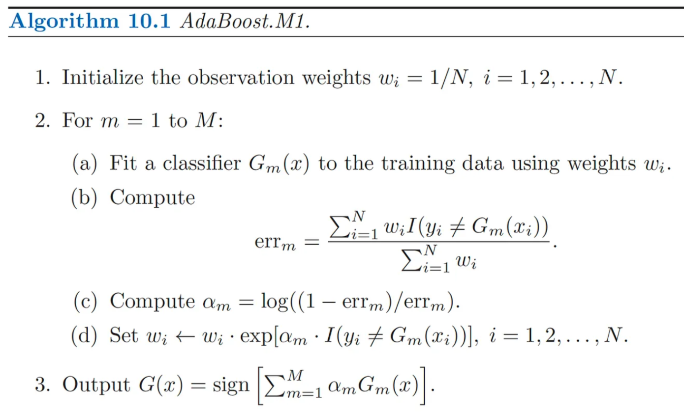

Figure 5: AdaBoost pseudo code

Now we will explain the algorithm:[7][8]

First, each training example receives equal weight. 1 / N.

Then, the following steps are executed in a loop M times - a predetermined number or according to the stopping criterion:

1. A weak classifier is trained by the data set G_m(x) and the current sample weights w_i during each iteration.

2. After training the weak learner, the algorithm calculates the error rate using the formula: the sum of the weights of the misclassified examples divided by the total weight. in the formula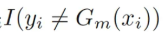 represents the number of examples that were incorrectly classified so that I=1 if correctly classified and 0 otherwise

3. The algorithm calculates the weight of the weak learner according to his error rate, the lower the rate, the greater the learner's weight.

4. Updating the sample weights of the training examples marked as alpha, those correctly classified have a lower weight and vice versa, the next new learner will focus more on the incorrectly classified examples.

After performing all these steps, the last step in the algorithm is performed and it is the combination of all the weak learners to create a strong and good classifier.

The contribution of each of the weak learners is determined and weighted according to his level of accuracy. (see figure 5)

### 2.2.6 Random Forest

An ensemble learning algorithm that combines predictions from many decision trees to improve accuracy and generalization. The randomness in the model is reflected in the selection of training data samples and in the features that are considered at each split in the tree. The algorithm collects the results of all trees, usually by majority voting, each tree is trained by a group of Data increases robustness and reduces overfitting. The algorithm can deal with high-dimensional arrays[9].

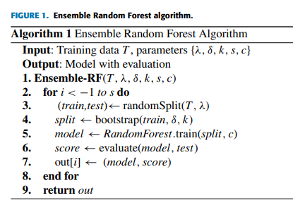

Figure 6: Random Forest pseudo code

[10]Now we will explain the algorithm:

First the algorithm starts by randomly selecting subsets of training data with replacement.

An ensemble function takes the training data `T` and the parameters `{λ, δ, k, s, c}` as input and its output is a collection of models with their evaluation scores.

After that, the steps we will describe now are carried out in a loop, S times - according to the parameter, the purpose of the loop is the creation of many random forest models with different subsets of the training data.

The training data T is randomly split into a training group and a test subgroup according to the parameter `λ' which determines the size of the training group in relation to all other data.

The bootstrap function randomly selects δ samples from the training set with replacement. The additional parameter 'K' determines the number of features that are considered in each split of the decision trees in the random forest model.

Now train the random forest model using the bootstrap function created in the previous step here the `c` parameter specifies additional parameters or hyperparameters used for training.

The trained random forest model is evaluated.

The trained random forest model is saved with its score in the out array.

After executing the loop, the algorithm returns the out array that includes the collection of trained models along with their evaluation scores.(see figure 6)

### 2.2.7 Support Vector Machine

SVM(support vector machine)[13] is a machine learning algorithm that used for classification, in general it puts all the data in m dimensions graph then find the best line which divide the dots in the graph into 2 groups, those who above and those who under the graph for prediction the algorithm puts the dots on the graph and check if the point is above or under the graph to predict which group it belongs

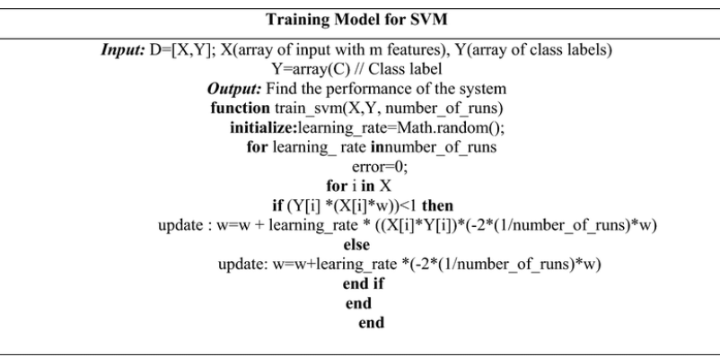

Figure 7: Svm pseudo code

**explanation about the SVM training algorithm:**The algorithm gets the data(X,Y) where X is the data (m features) and Y is the true labels of the data and the number of runs. it returns the performance rate of the SVM

The algorithm repeats for a number of runs time while in each run its check for each point is misclassified if so, it updates the weight vector ‘w’ to reduce the error. If the point is correctly classified, it applies regularization to the weight vector. (see figure 7)

### 2.2.8 k- nearest neighbors(k-NN)

KNN [12] It is a machine learning algorithm that is used for classification and regression, it stores all the training data points and their labels and according to them it predicts new data point labels based on the closest labels, i.e. their neighbors determined by a pre-selected number-K.

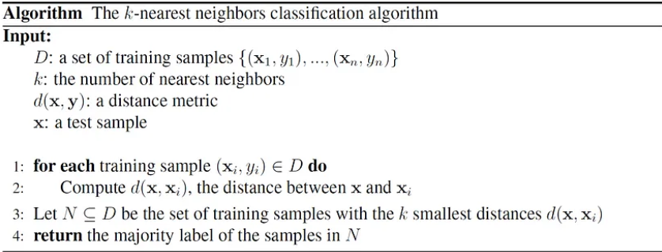

Figure 8: KNN pseudo code

Now we will explain the algorithm:

The algorithm receives the data (Xi,Yi) where Xi is the position of the point in the graph in Rn and Yi is its label (does it belong to group 1 or 2)

K - the number of neighbors by which we check

D the formula for calculating distance in Rn

and X is the point we want to test

For each point (Xi,Yi) calculate the distance between Xi and X using the formula D. Finally, we will take the K closest to it in terms of distance and check what their label is. The label of point X will be the most common label among the K points closest to it.(see figure 8)

### 2.2.9 Boruta features selection

Boruta features selection[14] algorithm is used to remove features that are statistically less relevant than a random probe.

how it works:   
1. shadow features creation- for each data point we shuffled the features   
2. concatenating the shadow features to data features and than add the true label

4.A random forest classifier (or another ensemble method) is trained on the combined dataset  
3. calculate importance of the features - original and shadow features importance are calculated by measuring the decrease in node impurity weighted by the probability of reaching that node, averaged over all trees in the forest.

4.if the score of a feature is under the max value of shadow feature the its considered as unimportant and “ delete it”   
5. save the important features into a new data set.

### 2.2.10 XGBoost

Extreme Gradient Boosting(XGBoost) is an iterative classification algorithm based on decision trees that designed to be highly efficient and flexible

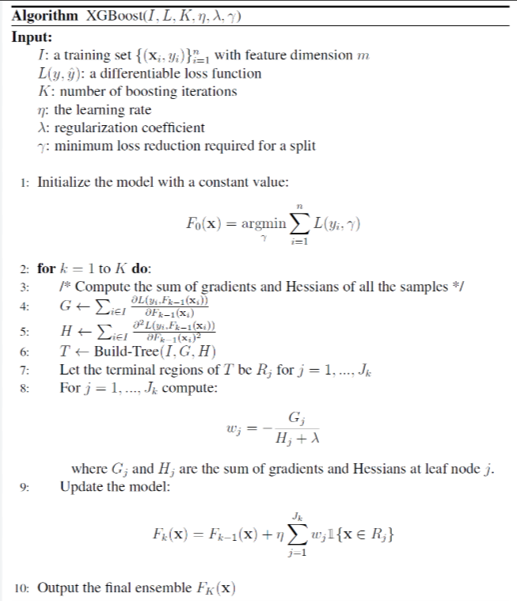

Figure 10: XGBoost pseudocode

Explanation:  
1. Initialize the constant prediction (default=0.5)

2.Run K times (K=number of iteration,default=100)

2.1 Compute G and H   
G-> Gradient Vector.  
For each data Xi and True label Yi find the distance between Yi and the last prediction for Xi(for K=1 prediction = initialized prediction.)   
H-> Hessians.   
For each Xi Hi=(last prediction for Yi * (1- last prediction for Yi)

2.2 build decision tree with G and H

2.3 compute Wi-> find the weight for each leaf in the decision tree. computed by

The sum of all gradients in the leaf divided by (all hessians in the leaf + **λ** (Regularization coefficient, default =0))

2.4 update last decision  
for each Xi compute current decision= last decision + η*Wj (when η is the learning which initialized while calling the function and Wj is the weight of the leaf Xi is part of

3. return current decision for each Xi

# 3. Proposed Approach

## “smelltify”

The application we provides includes all the algorithms we have seen above(see figures 3-8) and its goal is to find the best model that capable of identifying new smells, matching and classifying them with known smells according to numerous smell categories. Our algorithm based on an algorithm that have done the same process in order to classify between 2 groups of smell (see figure 9) [2] build with GUI and friendly interface in order to make it easy to use for the end user.

## 3.1 Architecture and technologies

  
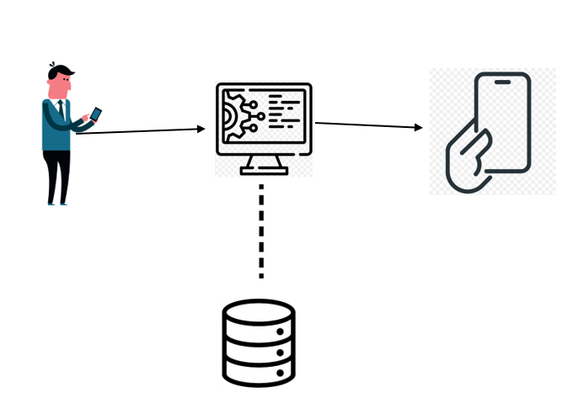**

## 3.2 Main architecture

As mentioned before our main Algorithm is taken from other research done for find the best model to classify between 2 main smells (see figure 9)



Figure 9: Overall workflow of model development for the classification tasks

input: the data D (X, Y) where X means an m features data and Y the data of the true label.   
output: the optimal model   
  
  
how it works:   
1. Divide the data into 2 groups (train ad test) in the ratio of 90:10   
2. On the train group make5 fold CV twice which one of them perform with oversampling the data from each group enter into Boruta in order to “ get rid” of unnecessary features and also save the original data ( in this part we will have 4 different datas- 5 fold without oversampling with and without boruta and 5 fold with oversampling with and without boruta)   
4. each group enter as data to GridSearch CV to find its best hyperparameters (for the classification algorithms)  
5.for each algorithm enters all the data (each data group is consider a train) as train and the test group from the beginning as a test and return the accuracy of each algorithm   
6. return the best model.

Our app makes an adoption of this algorithm to our use. Classify various amount of smell groups and make it usable for the end client (GUI)

# 4. Engineering Process

## 4.1 Process

We started our work on the project by reading and analyzing articles, first we dealt with articles that explain what a smell is and what are the difficulties in detecting and classifying smells. After that we continued to research about the algorithms that exist on this topic and finally, we researched about the main algorithm for smell classification according to which we will base the development of our algorithm for smell classification and identification. The algorithm that we want to implement knowes how to receive a vector describing a smell and classify and associate it with the smell to which it belongs.

## 4.2 Dataset

There are established methods to process scents into a database, but in our project, we use an existing database【16】. In the next phase of the project, we will focus on analyzing this database on which the algorithm will be trained and using it to develop our application. In practice, we will implement the main algorithm based on the algorithm we studied [2] that will allow the application to receive input from the user, which includes a description of a smell. The algorithm will analyze this input and output the level of accuracy of this smell compared to other smells in the database after it is trained. Essentially, our algorithm will classify and identify new smells based on their similarity to known smells from the database.

## 4.3 Challenges and solutions

During the course of working on this project, we encountered several challenges. The first issue was the limited dataset available to us. We had hoped to find a larger dataset that was better suited to the specific needs of our project. Despite extensive searching, we were unable to locate one that met our requirements. As a result, we had to make do with the dataset we found and adapt to the challenges it presented in terms of usability.

The second challenge was a lack of time. This year has been particularly difficult for all of us, marked by numerous disruptions, disappointments, and unforeseen events in the country, which caused significant delays in our work. However, despite these setbacks, we made every effort to manage the remaining time effectively and to achieve the best possible outcome given the constraints.

Additionally, we implemented the project using Preact, a framework we had not worked with before, which required us to quickly learn and adapt. Throughout the project, we encountered many new concepts and technologies, and we had to learn and apply them as we developed the code. Despite these challenges, we are proud of the progress we made and the knowledge we gained along the way.

## 4.4 Product

### 4.4.1 Use Case Diagram

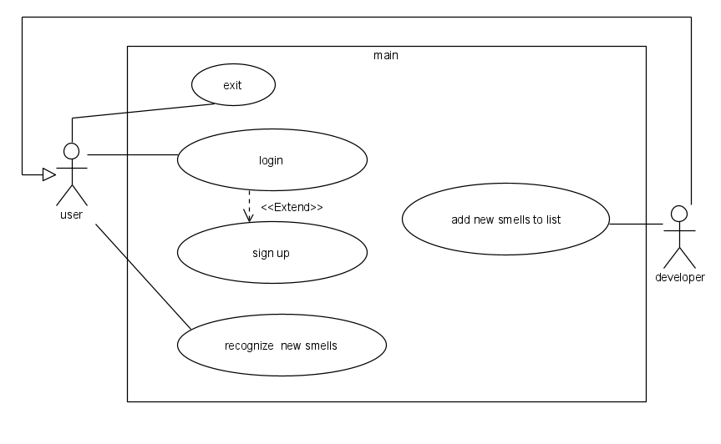

### 4.4.2 Activity Diagram

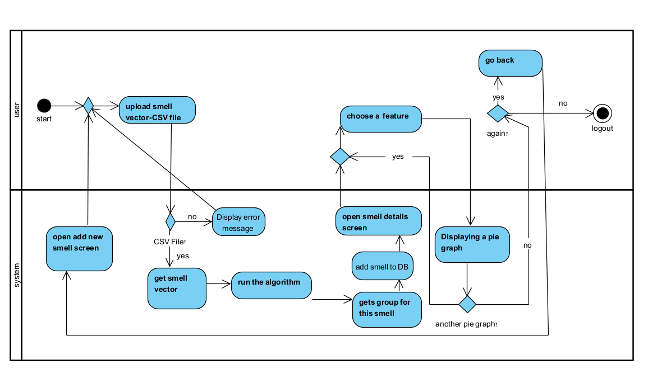

# 5. Verification

To ensure that our algorithm works efficiently and provides optimal results, we will use known odors with well-defined characteristics to ensure that we obtain absolute results in these cases. In addition, as we mentioned before, we will use the Principal Odor Map (POM) as a benchmark for the results we achieve in our algorithm development, to ensure that our approach is validated against an established standard and indeed produces better results.

**Login Screen**

1. Wrong password

Expectation: alert(incorrect username or password please try again)

Result:

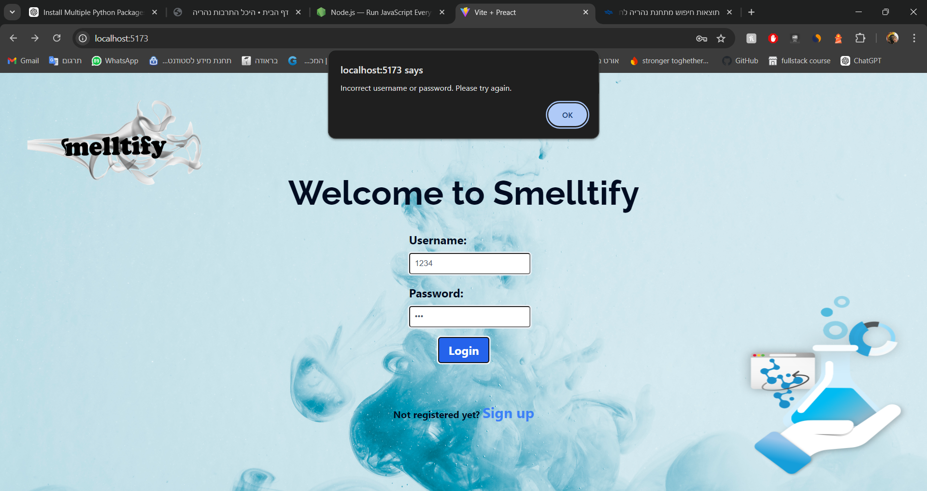

**passed**

2. successful login

Expectation: alert(Login successful) and rout to add smell page.

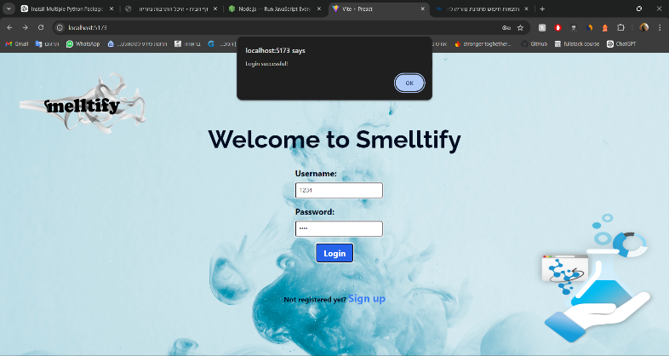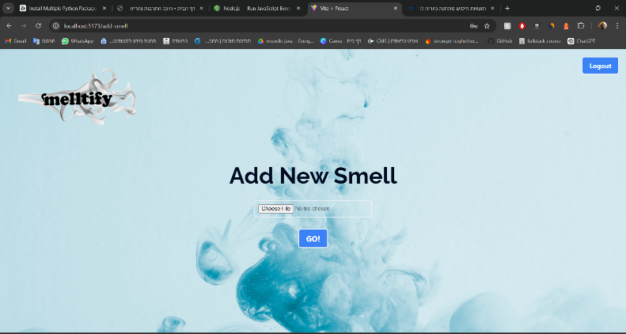Result:

**passed**

**Register screen**

1. Use existed username

Expectation: alert( Registration failed Username or Email already existed)

Result:

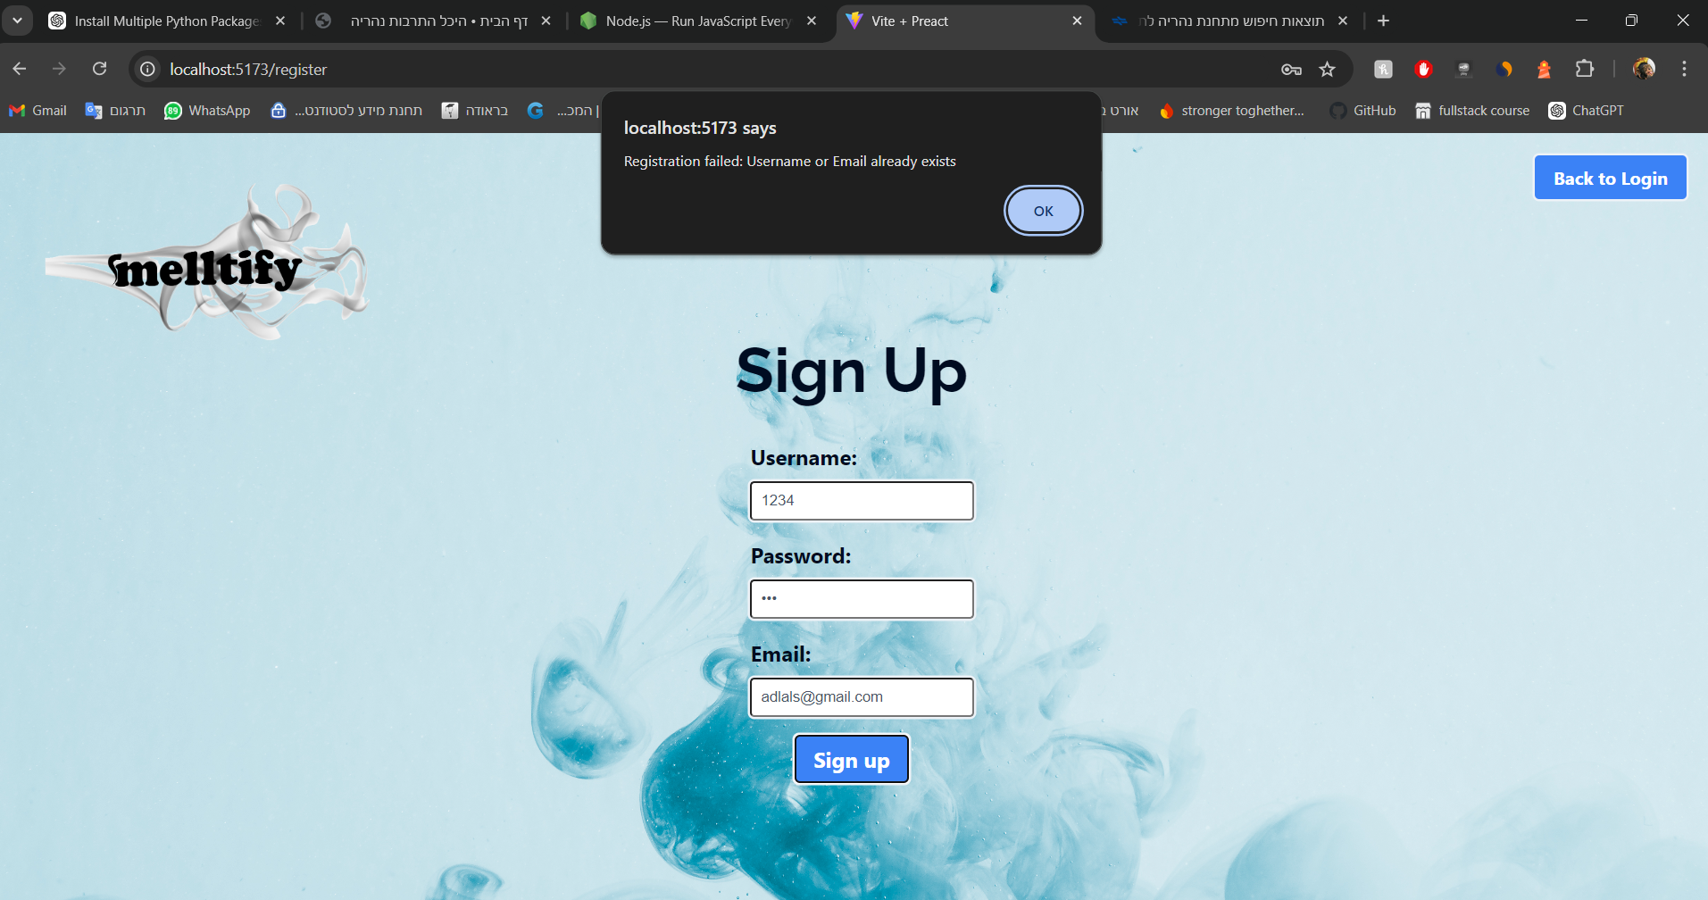

**Passed**

1. Use existed email

Expectation: alert( Registration failed Username or Email already existed)

Result:

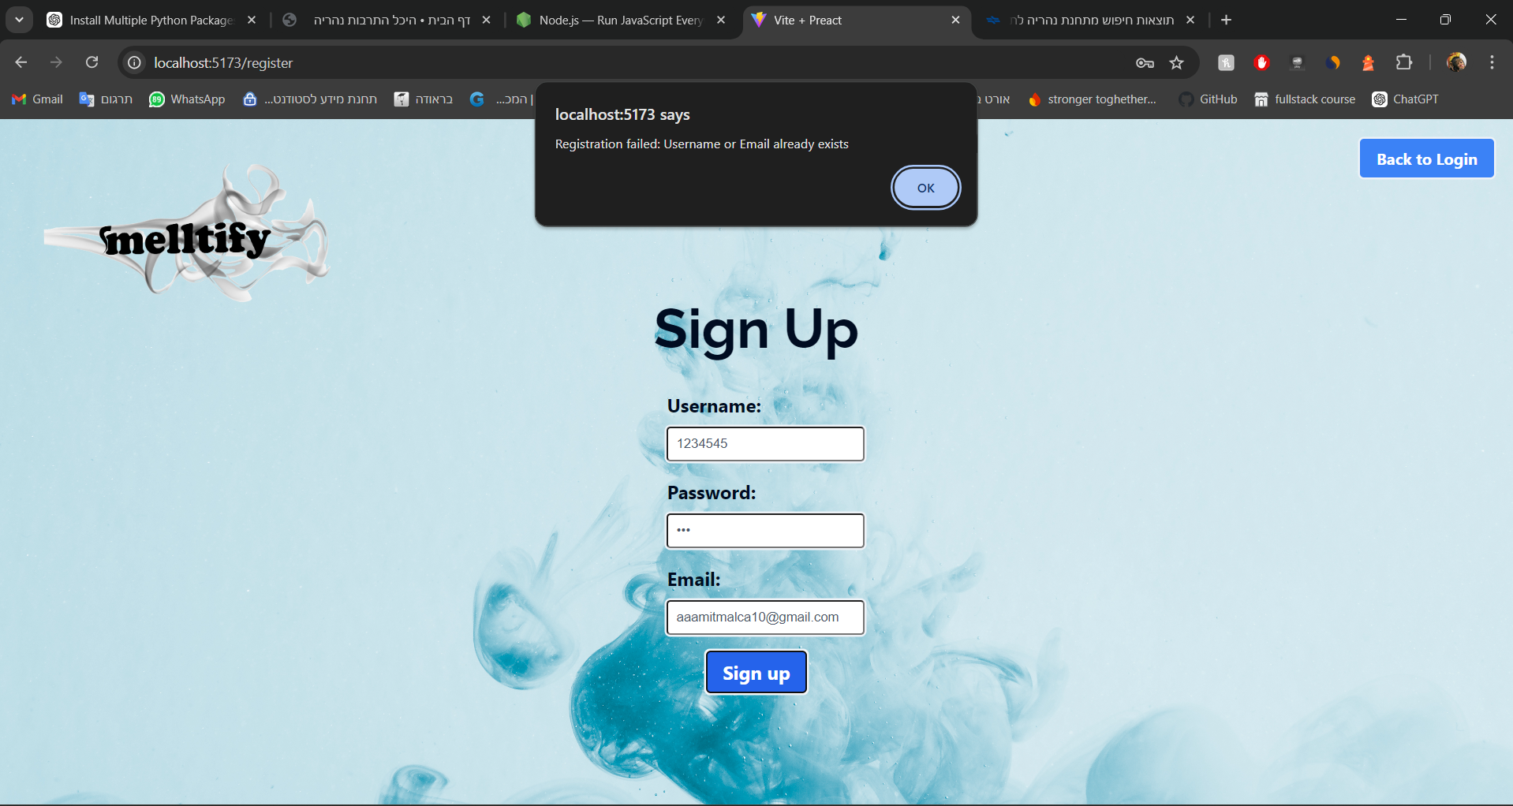

**Passed**

1. Successful registration

Expectation: alert(registration successful!)

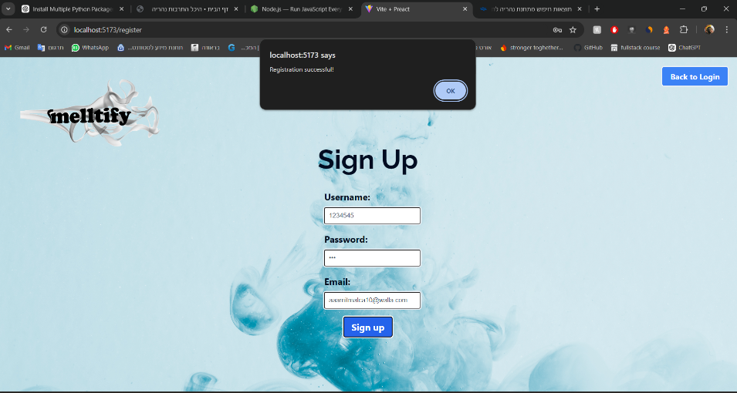Result:

**Add smell screen**

1.Too short CSV file

Expectation: alert(sorry, data must be in length of 138 bits per smell!)  
result:

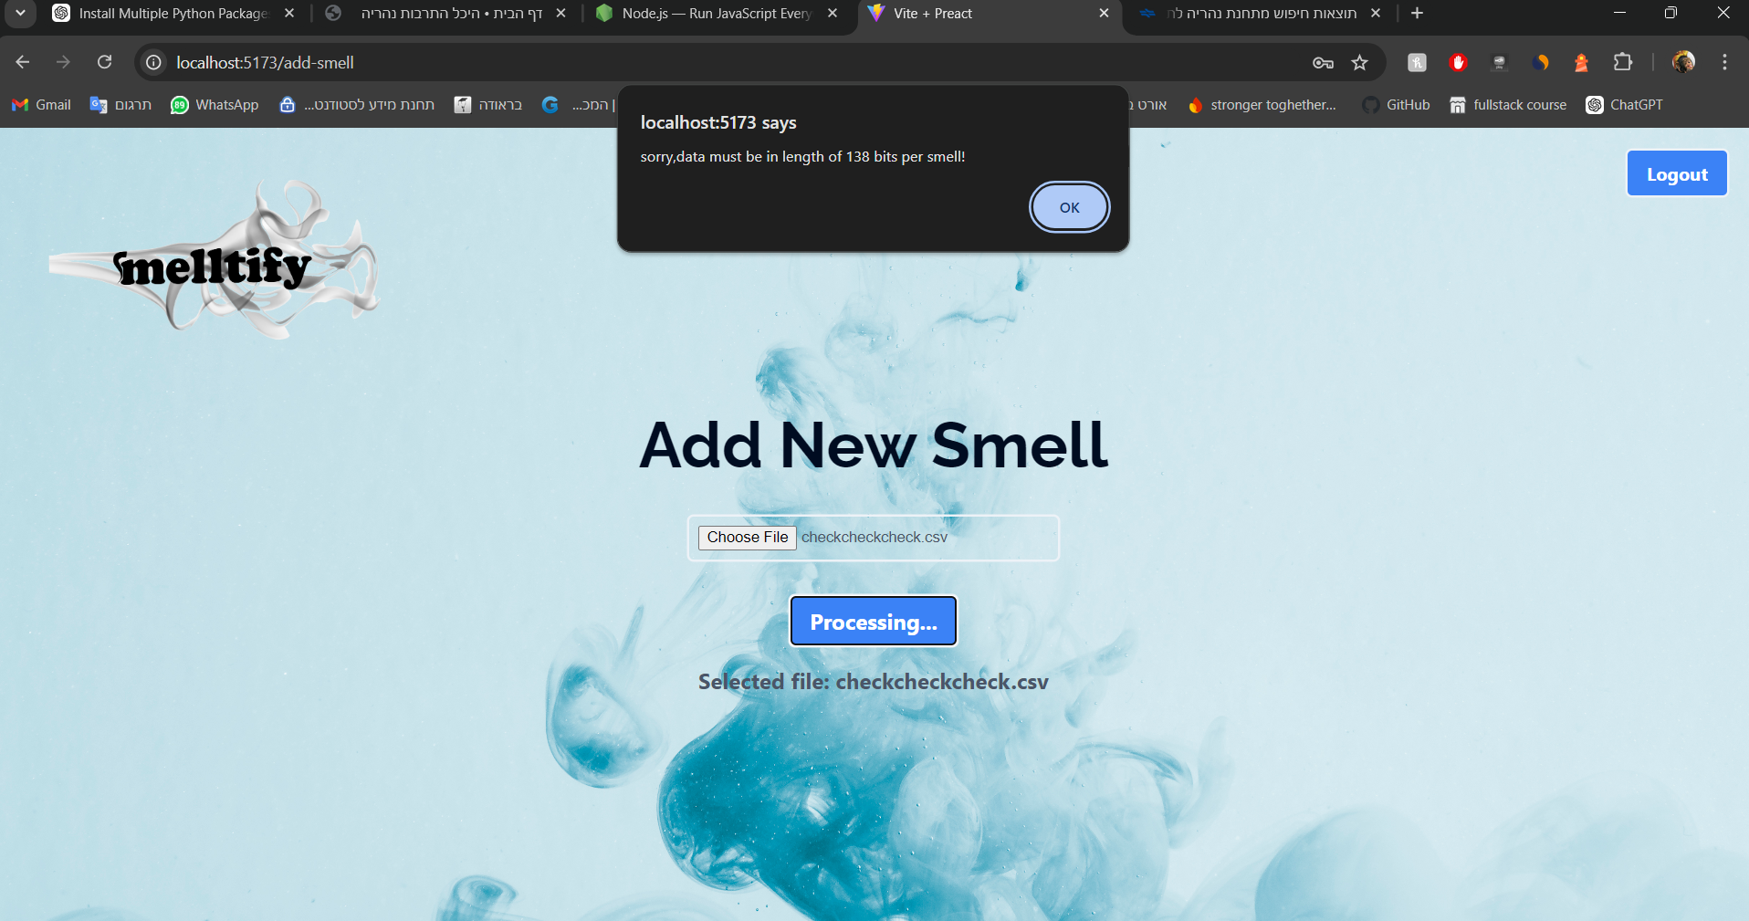

**Passed**

1. Try to upload not CSV file

Expectation: alert( please upload a valid CSV file)

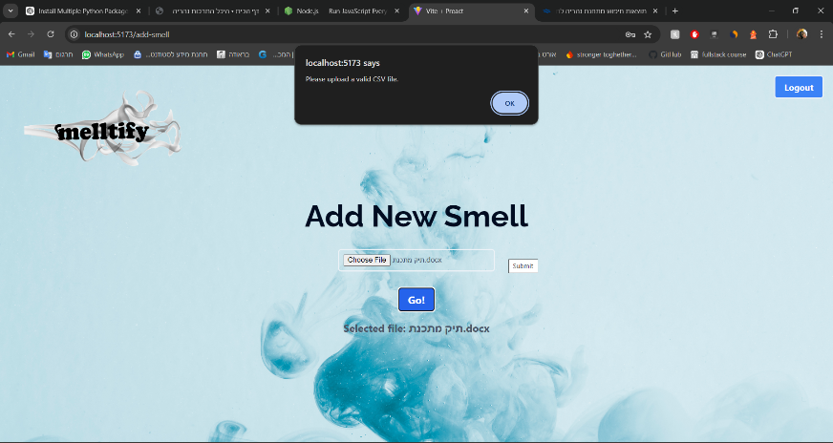Result:

**Passed**

1. csv with non binar numbers

Expectation: alert(sorry,data must be binar vector! please upload new file

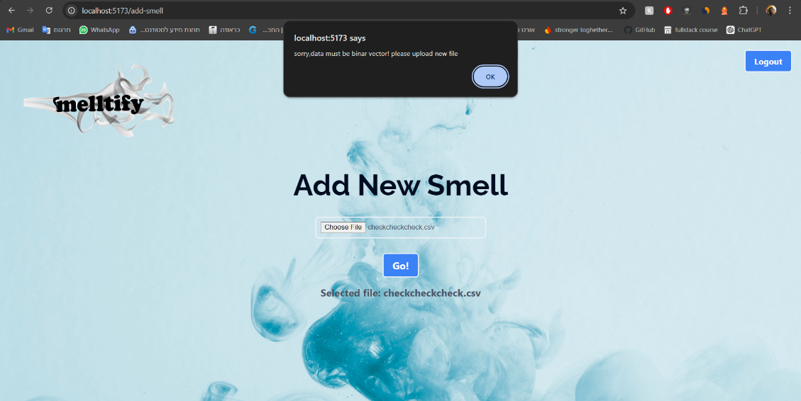Result:

**passed**

1. Valid CSV file

Expectation:alert(File uploaded and processed successfully!) and move to smell details page

Result:

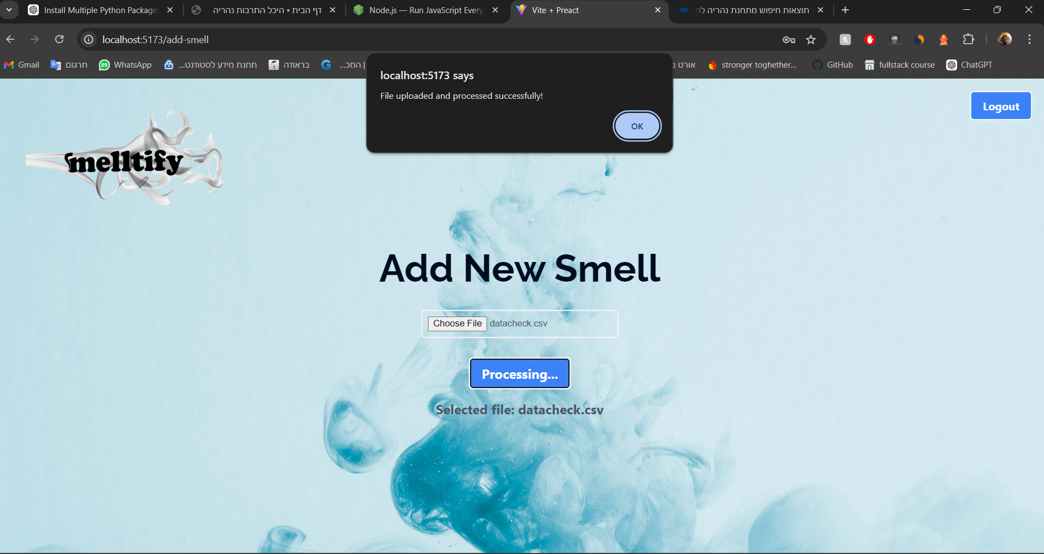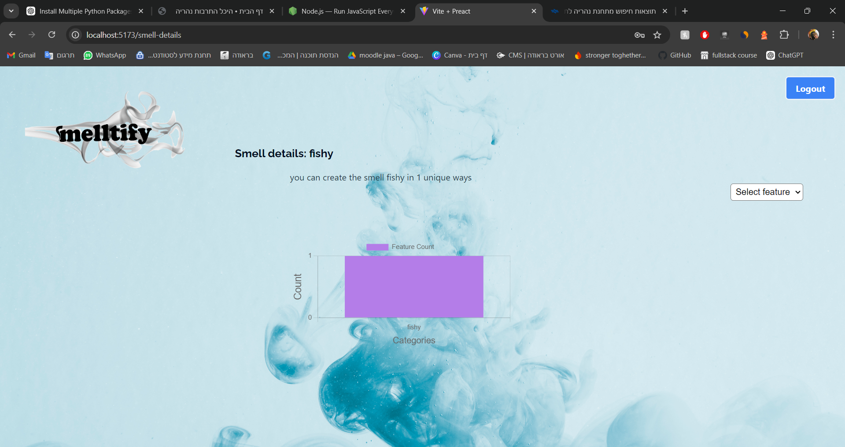

**Passed**

**Smell-details screen**

1. Pie chart created after feature change

Expectation: create valid pie chart   
result:

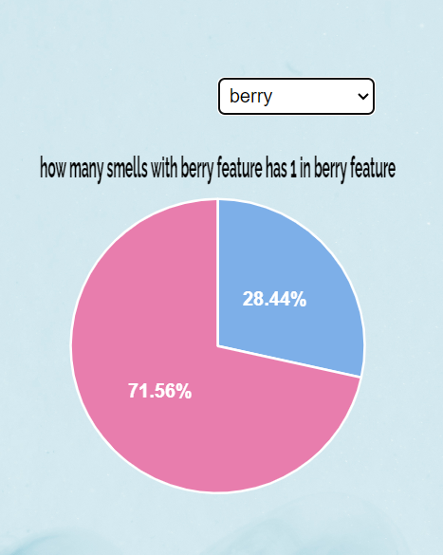

**Passed**

1. Smell entered predicted successfully

Expectation: for entered smell vector of fishy algorithm predict fishy

Result:



**Passed**

# 6. Results and conclusions

The best model we got after the tests is random forest.

We saw that there are features that can be created with the help of other features such as: apple, berry and more and those that are almost not like: alcoholic, balsamic, banana and more.

In addition, we were able to compare one smell against several smells so that our goal was achieved Random Forest reached results of accuracy between 85-93 percent so we significantly improved the accuracy from the previous models:

POM only reached 70 percent accuracy and the central architecture on which we based the code only reached 80 percent accuracy for the XGBoost algorithm.[1][2]

# 7.User Guide

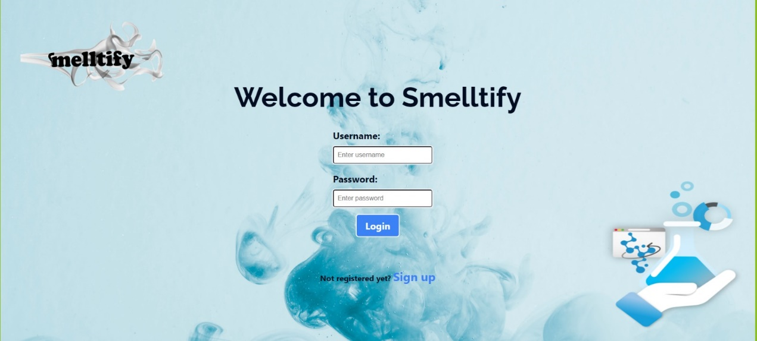

**home page**

(login)

1. Enter the username and password you created during registration.

2. Click the Login button.

If the details are incorrect, you will receive an error message: "Incorrect username or password."

If the user name does not exist in the system, a message will be received: "User not found."

If the connection was successful, you will be transferred to the Add Smell page.



**Registration page**

(register)

Fill in the following fields:

Username: Choose a unique username.

Password: Choose a strong password.

Email: Enter a valid email address.

Click the Sign Up button.

If the username already exists in the system, you will receive an error message: "Username already exists. Please choose a different username."

If the registration was successful, you will receive a success message: "Registration successful!".

* Back to Login: There is a button on the top right that allows you to log out and return to the login page.



**Add Smell page**.

After logging in, you will be taken to the Add Smell page.

Upload a CSV file with the scent information you want to add.

Click the Go button.You will be transferred to the Smell Details page, where the name of the identified smell will be displayed and in addition a pie graph with the percentages of the smells in different categories of which the smell is composed.

* Logout: There is a button on the top right that allows you to log out and return to the login page.

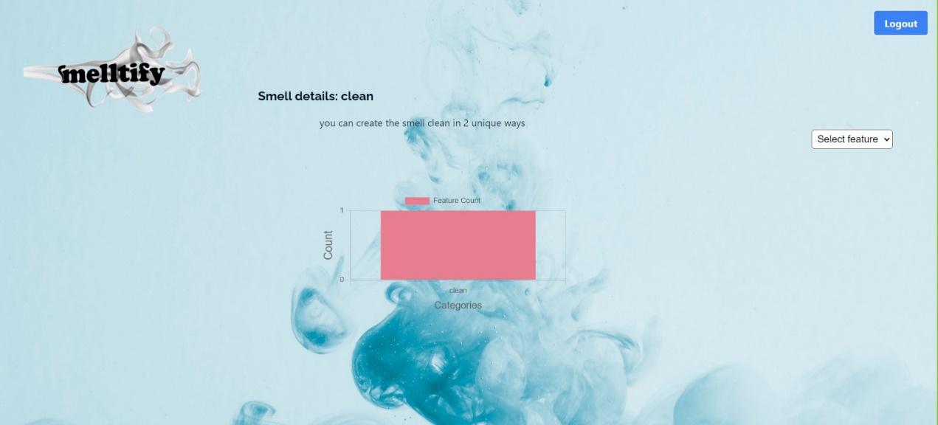

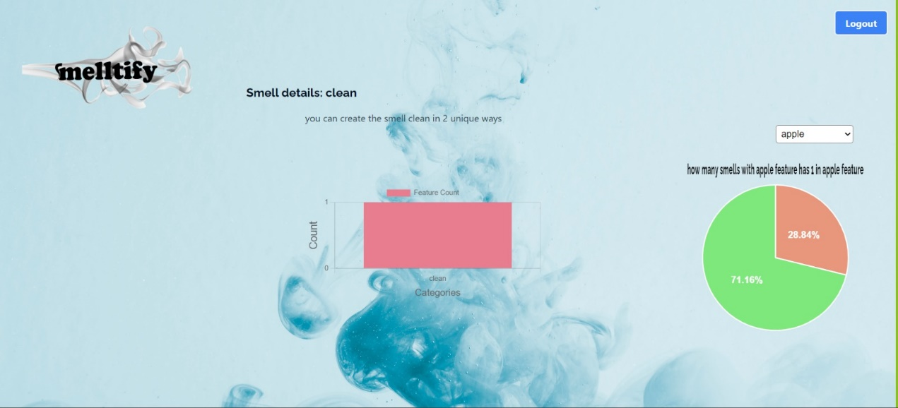

**SmellDetails page**

The name of the smell detected by the user is also shown to the user in how many ways the smell that he entered can be produced, that is, how many vectors make it up.

In addition, two graphs are shown:

A pie graph for each scent component that the user selects from a list according to the scent components found in the data set, describing the percentage of scents that contain the scent without using it and when using it and a bar graph depicting whether the resulting scent components were obtained by using them or in some other way i.e. whether their bit in the vector was on.

* Logout: There is a button on the top right that allows you to log out and return to the login page.

# 8. Maintenance Guide

# **Work Environment:**

Backend: The backend code can run on any environment that supports Python. We chose PyCharm as our development environment.  
Frontend: The frontend is developed using VSCode.

# **Installations:**

## Backend:

To install all necessary dependencies for the backend, open the project in any Python-supported platform and run the following command in the terminal:  
pip install -r requirements.txt

## Frontend:

To install all the required features for the frontend, first, install NodeJS on your machine from this link:  
<https://nodejs.org/en>

After installing NodeJS, run the following command in the terminal:  
npm install

# **Running the Project:**

## Frontend:

First, start the frontend. Navigate to the front project folder and run the following command in the terminal:  
npm run dev  
You should see an output like this:

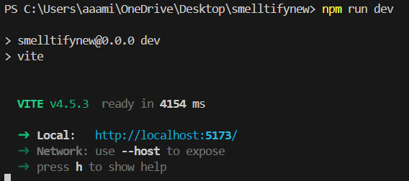Backend:

Once the frontend is running, navigate to the back folder and run the Python file back.py:  
python back.py  
The expected result should look like this:

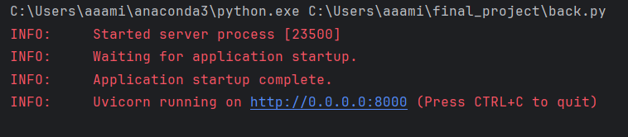Now you can start using the website! To access the site, copy the URL provided by the frontend and open it in any web browser.

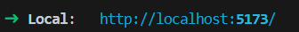

# **Important Notes:**

- Do not run the frontend more than once without stopping the previous instance.  
- To stop the running services:  
 - Frontend: Press Ctrl + C in the terminal.  
 - Backend: Stop it using the standard method.

# References

1.

<https://blog.research.google/2022/09/digitizing-smell-using-molecular-maps.html?m=1>

Gerkin, R. C., & Wiltschko, A. B. (2022). Digitizing smell: Using molecular maps to understand odor. Google AI Blog.

2.

Chacko, R., Jain, D., Patwardhan, M., Puri, A., Karande, S., & Rai, B. (2020). Data based predictive models for odor perception. *Scientific Reports*. https://doi.org/10.1038/s41598-020-73978-1

3.

<https://www.researchgate.net/publication/331292817_Machine_learning_models_for_early_sepsis_recognition_in_the_neonatal_intensive_care_unit_using_readily_available_electronic_health_record_data>

Masino, A. J., Harris, M. C., Forsyth, D., Ostapenko, S., Srinivasan, L., Bonafide, C. P., ... & Grundmeier, R. W. (2019). Machine learning models for early sepsis recognition in the neonatal intensive care unit using readily available electronic health record data. PloS one, 14(2), e0212665.

4.

<https://www.analyticsvidhya.com/blog/2021/06/tune-hyperparameters-with-gridsearchcv/>

5.

<https://scikit-learn.org/stable/modules/generated/sklearn.model_selection.GridSearchCV.html>

6.

Natekin, A., & Knoll, A. (2013). Gradient boosting machines, a tutorial. Frontiers in neurorobotics, 7, 21.

7.

<https://towardsdatascience.com/adaboost-from-scratch-37a936da3d50>

8.

<https://medium.com/@datasciencewizards/understanding-the-adaboost-algorithm-2e9344d83d9b>

9.

Belgiu, M., & Drăguţ, L. (2016). Random forest in remote sensing: A review of applications and future directions. ISPRS journal of photogrammetry and remote sensing, 114, 24-31.

10.

Weiwei Lin, Ziming Wu,Longxin Lin, Angzhan Wen and Jin Li (2017).’An Ensemble Random Forest Algorithm for Insurance Big Data Analysis’,IEEE Access,Digital Object Identifier 10.1109/ACCESS.2017.2738069

11.

[Support Vector Machine (SVM) Algorithm - GeeksforGeeks](https://www.geeksforgeeks.org/support-vector-machine-algorithm/)

12.

<https://medium.com/ai-made-simple/k-nearest-neighbors-knn-a-comprehensive-guide-7add717806ad>

13.   
<https://www.researchgate.net/figure/Pseudocode-for-training-the-SVM_fig3_338353198>

14.  
<https://towardsdatascience.com/simple-example-using-boruta-feature-selection-in-python-8b96925d5d7a>

15.

Bailey, Regina. "The Olfactory System and Your Sense of Smell." ThoughtCo, August 17, 2021. Accessed July 7, 2024.  
16. <https://www.kaggle.com/datasets/aryanamitbarsainyan/multi-labelled-smiles-odors-dataset/data>

17. <https://towardsdatascience.com/xgboost-the-definitive-guide-part-1-cc24d2dcd87a>